Visualization of trajectories in gravitational fields as geodesics in curved spaces

**(Abstract) This research concerns the visualization of the classical celestial dynamics in gravitational fields, including free-falling motion, Kepler orbit, two-fixed-one-movable motion and finally the general three-body problems via Jacobi metric and derived geodesic equations.** **Visualization is achieved through two distinct methods: one involves plotting the trajectory in the local coordinate system, while the other entails isometric embedding of the Riemannian manifold into three-dimensional Euclidean space. By Maupertuis’s principle and the Jacobi metric derived in the paper, it gives the suitable trajectory for free-falling and Kepler orbit and suitability survives for the long-periodic three-body problems. However, for Lagrange equilateral triangle solution, the geodesic curve pretends to veer off from the curve predicted by Newton’s equation. Consequently, this underscores the relation between linear stability of the system and the fittingness of the curves. To estimate the suitability, error estimation is made by constructing Numerical error function that takes plot interval and the curvature as parameter. Based on the given results, the embedding of free-falling and two-fixed-one-movable motion is conducted and gained 3-D geometrical figure that corresponds to each manifold of the system. In conclusion, the study introduces a method for three-body embedding, drawing upon insights gained from earlier methodologies. Based on the findings of this research, the study anticipates the potential extension of these results to encompass relativistic celestial systems in the future.**

**1. INTRODUCTION**

One of the most important implications of Classical mechanics is to be able to predict the future by knowing the past and present. The trajectories of three moving particles in a gravitational field, however, cannot be predicted analytically in general [1]. This challenging problem is called the three-body problem which has been discussed for over 300 years. Since the trajectory of particles cannot be obtained in closed-form, previous studies have used numerical analysis using Newtonian formulation to predict trajectories and find periodic orbits [2]. On the other hand, in studies that interpret the configuration space as a Riemannian manifold, the Kepler problem was isometric embedded into a 3-dimensional curved surface to understand the mechanical situation visually and the curvature of three-body problem was investigated to understand the problem geometrically [3, 4].

However, there are still two major difficulties to understand the three-body problem. First, despite numerical analysis must be used in three-body problem, the error occurred in numerical analysis cannot be quantified because the solution of three-body problem cannot be obtained as a function of time. This makes it difficult to compare the accuracy and computational cost between Newtonian formulation and formulation using geodesics. Second, whether isometric embedding is possible and isometric embedding map for free falling, moving two particle, and three-body problem have not been studied.

In order to understand the three-body problem more accurately, the study proposed the new formulation using geodesic equation which is equivalent to the Euler-Lagrange equation for Lagrangian system and quantified the error by constructing the error estimation function to compare the computational cost and accuracy between two different formulations. Finally, we suggest the method to find the isometric embedding map of configuration space to 3-dimensional curved surface for free falling, two-fixed-one-movable system, and general three body problem to understand the problem more visually.

**2. RESULTS**

1. Geodesic formulation and Jacobi metric

From Jacobi metric, the metric can be expressed as $dρ^{2}=g_{ij}dx^{i}dx^{j}=Tds^{2}=T\left(\sum_{ }^{ }{dx_{i}^{2}}\right)$ where $T$ is system’s total kinetic energy, $dρ$ for arc-length of geodesic curve on Riemannian manifold that corresponds to the system such as Kepler and three-body motion. Then the geodesic equation is given as follows:

$x_{k}^{''}=-\frac{∂T}{∂x_{i}}x_{i}^{'}x_{k}^{'}+\frac{1}{2T}\frac{∂T}{∂x_{k}}{\left(x_{i}^{'}\right)}^{2}$

Moreover, from the metric, $dρ=Tdt$ and Euler-Lagrange equation can be derived where $dt$ represents the time element. This all gives suitable result a shown in Fig. 2. (b).

1. Construction of error estimation function

Intuitively, errors of numerical analysis occur significantly when the points are marked at large intervals, and the direction of the trajectory changes a lot. To quantify the above relationship, we defined the distance between the plots as “plot interval” and “curvature” of trajectory as the parameter of error estimation function.

We set up an equation of numerical error that only depends on plot interval and curvature by Euler method. A hypothesis is that curvature of trajectory is locally constant. It means that, we can consider neighborhood of a point of the trajectory as arc which radius is 1/curvature. According to this hypothesis, the equation of numerical absolute error is $Absolute Error = \sqrt{r_{0}^{2 }+d^{2}}-r_{0 }$. The Fig. 1. (a) can compare theorical numerical analysis relative error and real numerical analysis relative error by curvature and plot interval. The mesh which is calculated by theorical numerical analysis relative error is almost correct to dots which are real numerical analysis relative error.

To compare Geodesic formulation and Newtonian formulation according to accuracy based on computational cost, we define ‘the mean of relative error’ which is $\frac{\sum^{ }{numericla} analysis relative error at each points}{number of points}$. In Fig. 1. (b), we set up x-axis as eccentricity for analysis the mean of relative error based on the degree of squishiness of the circle. This result shows that which formulation or eccentricity is more efficient.

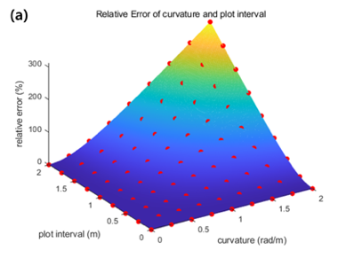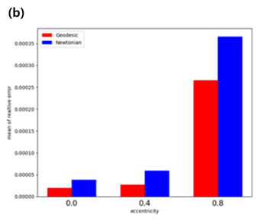

**Fig. 1. (a) Error estimation function parametrized by curvature of the trajectory and plot interval on Euler method. (b) Mean of relative error comparison between geodesic formulation and Newtonian formulation. The total energy is set to -0.05 J.**

1. Isometric embedding

It was concluded that embedding in Euclidean space is possible because the sectional curvature of free-falling is always positive in the $V=-y$ situation.

The map function that satisfies isometric condition can be defined as $\left(x, y\right) → \left(f\left(x, y\right), g\left(x, y\right), h\left(x, y\right)\right)$. We found the explicit functions

$$f\left(x, y\right)=\sqrt{t\left(y\right)}\cos{x}$$

$$g\left(x, y\right)=\sqrt{t\left(y\right)}\sin{x}$$

$$h\left(y\right)=\frac{t\left(y\right)\sqrt{\frac{4t{\left(y\right)}^{2}-1}{t\left(y\right)}} _{2}F_{ 1}\left(-\frac{1}{2}, \frac{1}{4}; \frac{5}{4};4t{\left(y\right)}^{2}\right)}{\sqrt{1-4t{\left(y\right)}^{2}}}$$

where $_{2}F_{ 1}$ is the hypergeometric function and $t\left(y\right) = y+E$. We want to construct the functions to be real-valued functions. Thus, we take the interval $y > -E+\frac{1}{2}$ such that the functions are real.

Consequently, we visualized isometric embedded curved surfaces in 3-dimensional Euclidean space for free-falling as Fig. 2. (a).

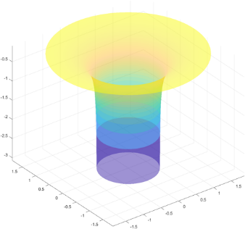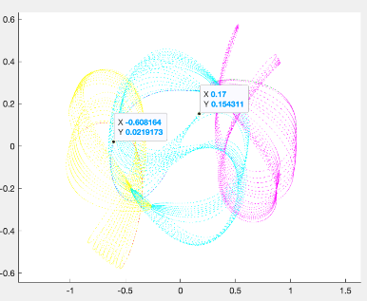

**Fig. 2. (a) Isometric embedded curved surface of free-falling for E = 0. (b) Geodesic curve of long-periodic three-body problem. m=[1,1,1], initial position=[-1 0;1 0;0 0], initial velocity=[ $v_{1}$ $v_{2}$; $v_{1}$ $v_{2}$; $-2v_{1}$ $-2v_{2}$] where $v_{1}=0.3232$** , $v_{2}=0.3279$.

Note the above Fig. 2. (b) shows that geodesic agrees with Newton’s equation anticipating the correlation of linear stability of the system and geodesic equation.

By analogy to free-falling and Kepler orbit [4], we can visualize isometric embedded curved surfaces in 3-dimensional Euclidean space for many-body system by solving the system of partial differential equations below.

$$f_{x}^{2}+g_{x}^{2}+h_{x}^{2}=T$$

$$f_{y}^{2}+g_{y}^{2}+h_{y}^{2}=T$$

$$f_{x}f_{y}+g_{x}g_{y}+h_{x}h_{y}=0$$

$T$ is kinetic energy of the system. Let $\vec{p}=\left(f, g, h\right)$ be a point vector of isometric embedded curved surface. Then, $\frac{∂}{∂x}\vec{p}=\left(f_{x}, g_{x}, h_{x}\right)$ and $\frac{∂}{∂y}\vec{p}=\left(f_{y}, g_{y}, h_{y}\right)$. Thus, the above system of partial differential equations means that

$$\left\langle \frac{∂}{∂x}\vec{p}, \frac{∂}{∂x}\vec{p}\right\rangle =T$$

$$\left\langle \frac{∂}{∂y}\vec{p}, \frac{∂}{∂y}\vec{p} \right\rangle =T$$

$\left\langle \frac{∂}{∂x}\vec{p}, \frac{∂}{∂y}\vec{p} \right\rangle =0$.

We can find information of the functions $f, g, h$ by using above equations and observing the situation that $x$ or $y$ is fixed.

**3. CONCLUSION**

In Fig .1. (a) numerical error function is almost correct to real numerical analysis dots. By using numerical error function and concept of discrete curvature, it can predict that which formulation has less numerical analysis relative error. When executing numerical three-body situation, it can choose Newtonian formulation or Geodesic formulation by accuracy and computational cost.

In isometric embedding in free-falling, it was confirmed that the geodesic and the real trajectory in gravitational field correspond. In the general situations for free-falling motion, isometric embedding was possible for all x, y ranges. The map function appeared as a single curved surface regardless of the energy conditions.

The study envisions that precise plotting such as Fig. 2. (b) and embedding of three-body problems can be achieved through the application of linear stability and the technique of embedding two fixed bodies with one movable body. Furthermore, these findings may have the potential for extension to relativistic systems, including the Schwarzschild metric or the propagation of gravitational waves resulting from compact binary coalescence etc.

**References**

[1] Musielak, Z. E., & Quarles, B. (2014). The three-body problem. *Reports on Progress in Physics*, *77*(6), 065901.

[2] Li, X., & Liao, S. (2017). More than six hundred new families of Newtonian periodic planar collisionless three-body orbits. *Science China Physics, Mechanics & Astronomy*, *60*, 1-7.

[3] Pin, O. C. (1975). Curvature and mechanics. *Advances in Mathematics*, *15*(3), 269-311.

[4] Moeckel, R. (2018). Embedding the Kepler problem as a surface of revolution. *Regular and Chaotic Dynamics*, *23*, 695-7